WWVB D-PSK-R project
A process to remove wwvb psk modulation allowing traditional phase tracking wwvb receivers to be used again.
Written by: Paul WB8TSL

Outline
This document will outline an approach to removing the new psk modulation on wwvb. This is by no means the only solution there are many alternates. But this is reasonably simple and inexpensive. It uses the technique of noting and remembering the phase of wwvb and detecting the phase change. Then flipng the phase of the incoming signal to eliminate the phase change. This is a modification proven to work with the spectracom family of receivers of the 8XXX series circa 1994.
Byproducts of the solution are;
Phase shift data.
Phase corrected AM signal suitable for timing receivers such as the 8170
Phase corrected and limited (AM suppressed) rf for phase tracking receivers.
Several other comments. I do have multiple pictures of the solution. But they are each 2 MB in size as such I can’t include any of them and still share this on time nuts. I also have graphs of the d-psk-r and a traditional fluke 207 non corrected. I am afraid even the schematics going to be far to large. Will have to see. But the schematic really is the key.

Details and history
When WWVB made the first announcements in March, many time-nuts realized that their old receivers were no longer going to work. Many commented. In the background some of us time-nuts started to kick ideas around. But that slowed and died pretty quickly. However since I have a farm of receivers I needed a solution. There is a time-nut or 3 that has made numbers of suggestions that we tried. Most theoretically work. But with the propagation to the east coast most were actually failures. It became apparent I needed a better antenna. Plus I have to fight MSF out of England. So a 10’ square loop was built with about 800’ of wire. A new preamp added and this was set 140’ from the house out in the woods. My signals went from 20uv to 80uv in the day and 200-300uv at night. So that helped the testing.
I wanted to build a free standing receiver not dependent on any receiver I had but the fact is 6 months has gone by with many false starts. So I hacked a spectracom 8163 receiver that was kindly donated by another time-nut. This is that design and it does work. Can absolutely be improved.

The following schematic shows the solution.
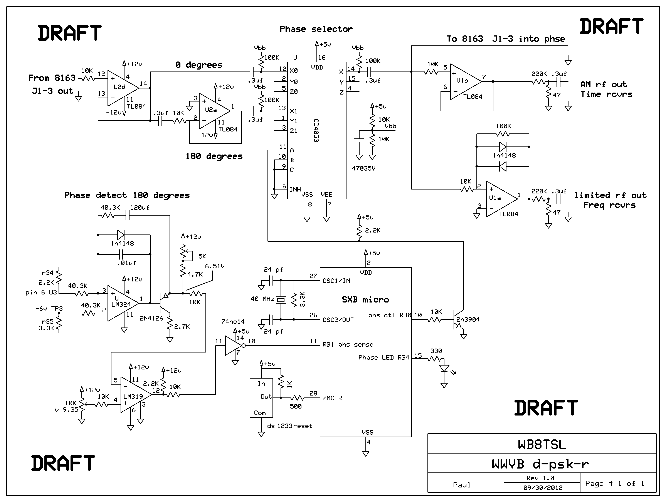
Description
Starting at the top left is the 60 Khz crystal filtered RF from the 8163 receiver daughter card. The path to the phase detectors is cut and feeds to this new set of circuits. U2d is a buffer and feeds one side of a cmos switch. The other output of the buffer goes to an inverting stage U2a and that then feeds the switch. The switch selects either 0 or 180 degree rf to feed the remaining processing .
One output feeds back into the 8163 to feed the original phase detectors. The other two paths deliver a compressed reduced am rf signal for phase tracking receivers and a AM modulated RF for time decoding receivers.
The real ket to the system is the phase detection and it actually uses the original phase detectors of the 8163. The 0 degree detector remains the same and controls the original 8163 VCO at 10 Mhz.
It’s the 90 degree detector that holds the secret to phase detection. By tapping into its output and adding the exact same circuit as the 0 phase detector a phase voltage is created. So looking at the lm324 and 2n4126 this is the exact same components as the 0 phase detector. None of the other parts of the 90 degree detector are touched. So that the AGC and AM detection are preserved.
The output of the 90 degree detector passes to a comparator and the slice voltage set at about 7 vdc by the lm319. This signal is buffered and inverted and feeds a fast processor called a SXB. The SXB samples the voltage and determines if a phase flip has occurred and then flips the cmos switch if it has.
This removes the PSK. The phase voltage is processed and filtered and evaluated over at least 3 cycles of the WWVB signal. The switch is flipped and also a LED is turned on or off depending on the switches state. The programs very simple and many other small procs could do the job if they are fast enough.
This is also were the most processing gain might be had with further work.
The SXB is nice because it programs easily in basic. Program below. It also at 40 Mhz executes the complex instructions in 300-500ns. So a lot of time is left over.
' WWVB de psk er
' 09/08/2012 uses a new 90 degree phase detector opamp from u3 on 8163
'This approaches uses a constrained RF channel so phase flip causes loss of rf
'The 90 degree detector detects that incoming is at 0 or 180 and that triggers rf state change
' This actually is working used a lm319 comparator looking for V out from 10-12 V if so flip
' Add in comments and filter for noise 3 highs 50 usec apart flip
DEVICE SX28, OSCHS3, TURBO, STACKX, OPTIONX
FREQ 40_000_000
' ____________ PIN assignments ___________________________________________________________
Led0 PIN Rb.5 output 'grn led hi drv
Phasectl PIN Rb.0 output 'Hi = 0 phase Lo = 180 degrees
stb0 pin Ra.0 output 'status pins for scope triggers
phasein PIN Rb.1 input '90 degree phase sig red grnd green
'if 0 flip phase
PROGRAM Start
Start:
low phasectl ' set phase to 0
low led0
low stb0
agn:

do while phasein = 0 'LM319 low when wrong but hit cd4093 inverter so flips hi
loop
pauseus 50 'wait for 3 highs 50 usec apart
if phasein = 0 then agn
pauseus 50
if phasein = 0 then agn
pauseus 50
if phasein = 0 then agn

high phasectl
high led0
high stb0
low stb0
pause 15 'pause for jitter
agn1:
do while phasein = 0
loop
pauseus 50 'wait for 3 highs 50 usec apart
if phasein = 0 then agn1
pauseus 50
if phasein = 0 then agn1
pauseus 50
if phasein = 0 then agn1

low phasectl
low led0
high stb0
low stb0
pause 15 'pause for jitter
GOTO agn
Other comments
The system has been tested over a 6 day period. During that time WWVB actually did not run PSK many days so it has about 48 hours of honest run time. What I have seen is that on occasion it does slip phase. At diurnal shift as an example. But then runs for 8 or more hours just fine. As compared to the fluke 207 that’s flipping all over the place during the same time period. Would love to add a graph or two. But again concerned on message length. Fun stuff.
There are several time-nuts who have helped in this project guidance, ideas, and hardware and I want to thank them. I am also trying a true costas loop but that’s been going slow. Just not enough time.

