Austron 2000c new GRI generator
03/23/2010

Written by: Paul Wb8-tsl

Summary
This document describes a new GRI generator for the Austron 2000c precision time receiver.
The goal is to allow the reception of European LORAN c stations by the use of a new GRI delay generator that allows for 10 usec GRI selection.
Essentially a single chip inexpensive solution replaces the old divider chain. It includes the known GRIs in use in Europe.
Just as easily other GRI rates could be used.
This information is provided on a completely non commercial basis there are no implied warranties or support.

Details
The system consists of a single IC programmed with the new GRIs. This chip is a Parallax SXb 28 chip.
The programmer and blank reusable chips can be purchased from the following site.
http://www.parallax.com/tabid/138/List/0/CategoryID/15/Level/a/SortField/0/Default.aspx

Hardware
The following schematic depicts the solution.
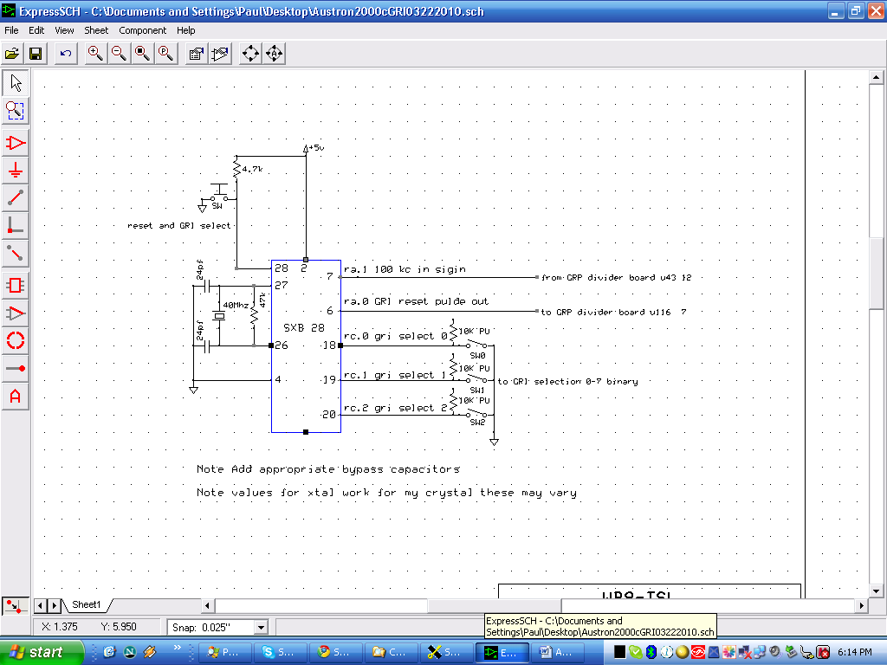
5 volts and ground are delivered to the microprocessor from the GRI board. A push button serves two functions.
1) reset the micro processor
2)reset the gri to a new rate
The clock is a 40 Mhz crystal any should do but you may need to adjust the 2 X 24 pf capacitors and the 47Kohm resistor.
The micro processor uses 100 KC from the GRI board available at U43 pin 12.
This establishes the precise timing and the minimum GRI delay increment of 10 usec.
The software counts the100 Khz pulses an puts out a reset pulse on pin 6 at the correct delay time that goes back to the GRI board and connects to U111 pin 7. The old trace from the old delay generator must be cut and is not used.
The 3 inputs from the switch select the GRI that’s desired. Each switch is pulled up to + 5 volts through a 10 K pullup resistor.
The switch settings are as follows in binary. 0 is on and a low
Switch GRI
0 59300 Canadian NE chain good for 6 months maybe
1 60000
2 67310
3 70010
4 74990
5 90070
6 10000 just a test frequency
7 10000
The chip can easily handle many more GRI rates if needed.

Software
The program is very simple and included here.
Simply cut and paste this into the SXB free development system and you can adjust the code and add new rates. Then program the chip.
____________________________________________________________________________________
'Austron 2000c.SXB
'New GRI delay gen that allows 2000c to use european LORAN c that increments in 10 us GRI
'Created 02/25/2010
'This is working as is on 03052010
'Note select dip switch and push reset button (this has been in use 3 weeks
'Counts 10us ref pulses for GRI delay send 2 us reste to u111
'This program may not be used for commercial purposes. Its intended amatuer use only.

DEVICE SX28, OSCHS2, TURBO, STACKX, OPTIONX
FREQ 40_000_000

Led PIN RA.0 'GRI out reset
sigin PIN RA.1 input 'character in signal
griswitch PIN RC input 'GRI dip sw select
gricount var word
gri var word 'GRI delay
griswitcha var byte 'Variable for the $07 and function

PROGRAM Start
Start:

griswitcha = griswitch and $07
lookup griswitcha, 5930, 6000, 6731, 7001, 7499, 9007, 1000, 1000, gri
'Dip on = 0 0 1 2 3 4 5 6 7
again:
high Led
pauseus 2
low led
for gricount = 1 to gri
do
loop until sigin = 1
do
loop until sigin = 0
next

goto again
Doesn’t get much easier then this for real time programming.

